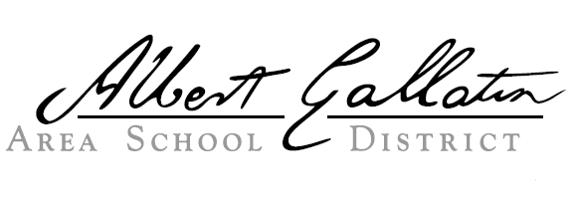
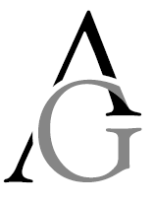

George J. Plava Elementary
120 Puritan Road, McClellandtown, PA 15458
Phone: 724-737-5424 FAX: 724-737-5120

Dr. Eric Witt, Principal Tracey Hackney, Secretary

Parent Right to Know Information as Required by The Elementary and Secondary Education Assistance (ESEA) [Section 1112(e)(1)(A)] and the Every Student Succeeds Act [Section 1112(e)(1)(A)]

Dear Parent(s)/Legal Guardian(s):

Your child attends George J. Plava Elementary which receives Federal Title I funds to assist students in meeting state achievement standards. Throughout the school year, we will be providing you with important information about this law and your child’s education. This letter lets you know about your right to request information about the qualifications of the classroom staff working with your child.

At George J. Plava Elementary, we are very proud of our teachers and feel they are ready for the school year and are prepared to give your child a high-quality education. As a Title I school, we must meet federal regulations related to teacher qualifications as defined in ESEA. These regulations allow you to learn more about your child’s teachers’ training and credentials. We are happy to provide this information to you. At any time, you may ask:

- Whether the teacher met state qualifications and certification requirements for the grade level and subject he/she is teaching,
- Whether the teacher received an emergency or conditional certificate through which state qualifications were waived, and
- What undergraduate or graduate degrees the teacher holds, including graduate certificates and additional degrees, and major(s) or area(s) of concentration.

You may also ask whether your child receives help from a paraprofessional. If your child receives this assistance, we can provide you with information about the paraprofessional’s qualifications.

The Every Student Succeeds Act (ESSA) which was signed into law in December 2015 and reauthorizes the Elementary and Secondary Education Act of 1956 (ESEA) includes additionally right to know requests. At any time, parents and family members can request:
- Information on policies regarding student participation in assessments and procedures for opting out, and
- Information on required assessments that include:
  - subject matter tested,
  - purpose of the test,
  - source of the requirement (if applicable),
  - amount of time it takes students to complete the test, and
  - time and format of disseminating results.

Our staff is committed to helping your child develop the academic knowledge and critical thinking he/she needs to succeed in school and beyond. That commitment includes making sure that all of our teachers and paraprofessionals meet applicable Pennsylvania state requirements.

If you have any questions about your child’s assignment to a teacher or paraprofessional, please contact Dr. Eric Witt at George J. Plava Elementary School at 724-737-5424 or email me at eric.witt@agasd.org.

Sincerely,

Dr. Eric Witt

